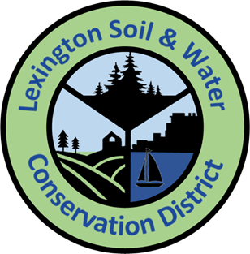
2023-2024 Conservation Mini-Grant Application

Please respond to the following questions. Expand response areas and attach additional pages as necessary.

Applicant’s Name: ____________________________Title/Position: ______________________________

Applicant’s E-mail: ____________________________Applicant’s Phone: __________________________

School: _______________________________________________________________________________

School Address: ________________________________________________________________________

Principal’s Name: ______________________________Principal’s E-mail: _________________________

- Project Title:

- Describe the proposed project and how it will promote natural resource conservation and education.

- I am applying for
___ $250 ___$500

- Project Budget (add additional rows as necessary):
Item | Unit Cost ($) | Quantity | Total Cost ($)
Total ($)
Any tools or equipment, not outlined in the proposal, and purchased with the grant money will be considered the property of Lexington Soil & Water Conservation District,

- If your proposed project will cost more than $500 (the maximum amount of the mini-grants), how will the rest of the project be funded?

- Project timeline: Describe your project’s timeline.

- Student Involvement:
  - How many students will be involved with this project? List by grade.
  - How will students be involved with this project?

- Collaboration: Describe if and how other faculty members, staff, parents, project mentors, or community volunteers will be involved with the project.

- Educational Outcomes: How will this project enhance student learning? If appropriate, include any state or local academic standards this project will be used to address.

- Optional Supporting Materials: Letters of support, or other materials demonstrating why your project deserves to receive a Conservation Education Mini-Grant. (Tip: At least one letter of support and at least one photo are recommended. These may be submitted, along with the application, via US Mail, E-mail, or fax per the instructions below.)

- Administrator certification: A school administrator (principal or headmaster) must certify that they are aware of this grant proposal, support the proposed project, and, if the project is selected for funding, will allow the project to be installed or completed on school property. Please have your school administrator either sign on the line below OR submit a separate certification (via US Mail, E-mail, or fax per the instructions below) acknowledging their support for this project.

_______________________________________________ _______________________
Principal’s Signature Date

Funds will not be distributed until, photographs and a write up of the completed project have been sent to LSWCD.

Submit your application and any optional supporting materials by US Mail, E-mail or deliver to:

Lexington Soil and Water Conservation District
Atten: Mini Grant Application
123 Park Road
Lexington SC 29072

krooflswcd@gmail.com
nwalkerlswcd@gmail.com

Application Deadline is December 31, 2023

